Anil NingeGowda

[Email address]

OOAD Assignments

# Assignment 1 - [Classes Student and Teacher](https://www.exercisescsharp.com/2013/04/601-classes-student-teacher.html)

**Application type: Console application**

**Problem statement**

* Create a new project, and include in it the class Person that you just created.
* Create a class "Student" and another class "Teacher", both descendants of "Person".
* The class "Student" will have a public method "GoToClasses", which will write on screen "I’m going to class."
* The class "Teacher" will have a public method "Explain", which will show on screen "Explanation begins". Also, it will have a private attribute "subject", a string.
* The class Person must have a method "SetAge (int n)" which will indicate the value of their age (eg, 20 years old).
* The student will have a public method "ShowAge" which will write on the screen "My age is: 20 years old" (or the corresponding number).
* You must create another test class called "StudentAndTeacherTest" that will contain "Main" and:
* Create a Person and make it say hello
* Create a student, set his age to 21, tell him to Greet and display his age
* Create a teacher, 30 years old, ask him to say hello and then explain

# Assignment 2: Photo Album

* Create a class "PhotoAlbum" with a private attribute "numberOfPages."
* It should also have a public method "GetNumberOfPages", which will return the number of pages.
* The default constructor will create an album with 16 pages. There will be an additional constructor, with which we can specify the number of pages we want in the album.  
  Create a class "BigPhotoAlbum" whose constructor will create an album with 64 pages.
* Create a test class "AlbumTest" to create an album with its default constructor, one with 24 pages, a "BigPhotoAlbum" and show the number of pages that the three albums have.

# Assignment 3: Orders

* Using Visual Studio, create a project and the corresponding classes (using several files) for this classes diagram.
* Each class must include the attributes and methods shown in the diagram. Consider that all cardinalities are 1:1.

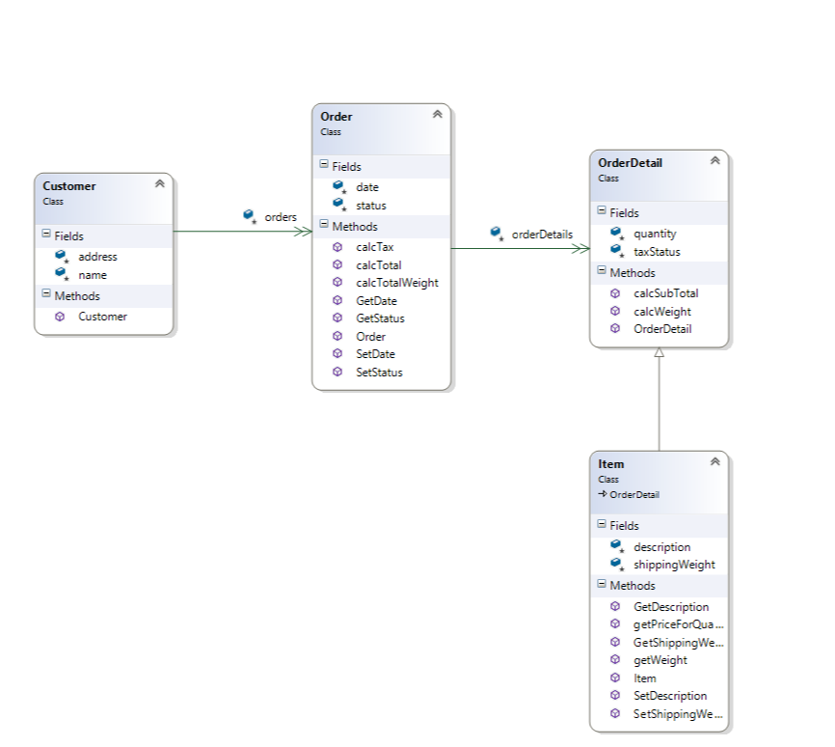

# Assignment 4: Catalog

* Create the classes diagram and then, using Visual Studio, a project and the corresponding classes for a catalog utility:
* It will be able to store information about music files, films and computer programs.
* For each item, it must store: name, code, category and size. For films it must also hold the director, the main actor and the main actress. For music files, the singer and the length (in seconds).
* For music and movies it must have a method "Play" (not implemented yet) and also a method "RetrieveInformation", which will (in a later version) connect to an internet server to get information about it.
* Use inheritance if needed. In "Main", create arrays of each kind of object.

# Assignment 5: Table

* Create a class named "Table". It must have a constructor, indicating the width and height of the board. It will have a method "ShowData" which will write on the screen the width and that height of the table. Create an array containing 10 tables, with random sizes between 50 and 200 cm, and display all the data.

# Assignment 5.1: Coffee table

* Create a project named "Tables2", based on the "Tables" project.
* In it, create a class "CoffeeTable" that inherits from "Table". Its method “ShowData", besides writing the width and height, must display "(Coffee table)."
* Create an array that contains 5 tables and 5 coffee tables. The tables must have random sizes between 50 and 200 cm, and the coffee tables from 40 to 120 cm. Show all their data.

# Assignment 5.2: Coffee table with Legs

* Extend the example of the tables and the coffee tables, to add a class "Leg" with a method "ShowData", which will write "I am a leg" and then it will display the data of the table to which it belongs.
* Choose one table in the example, add a leg to it and ask that leg to display its data.

# Assignment 6: Vehicles

* Using Visual Studio, create a project and the corresponding classes (using several files) for this classes diagram.
* Each class must include the attributes and methods shown in the diagram, as well as Get and Set methods for Vehicle and "Has" methods ("HasDualSlidingDoors") for MiniVan.
* You must create also a test program, which will create an object belonging to each class and tell it to "Drive".  
    
  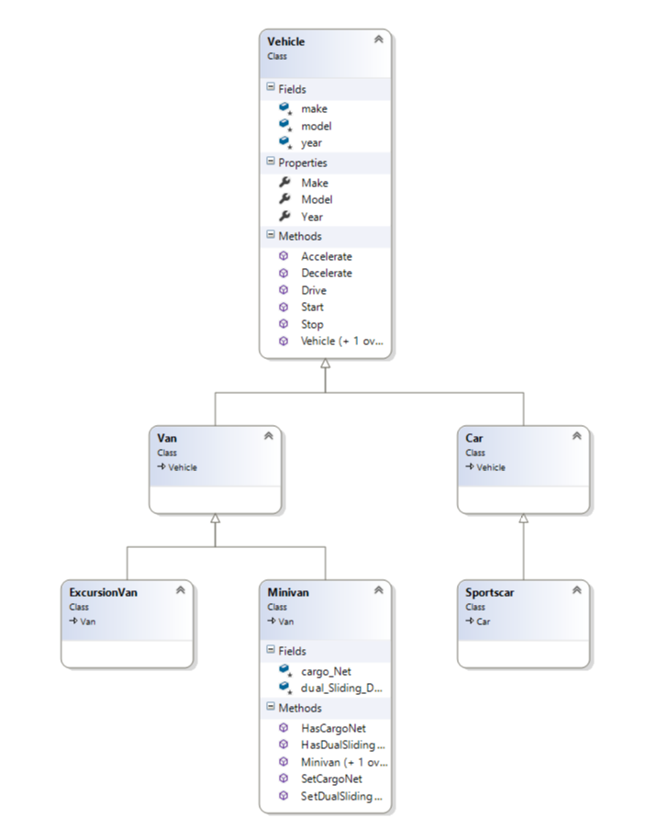

# Assignment 7: Coffee vending machine

Coffee vending machine – problem statement and review <https://www.youtube.com/watch?v=ATcJaczgJRU>